**02/11/2021 CD LAB 8 2019103573**

**1)Write a yacc program to implement arithmetic operators.**

**CODE :-**

**lex**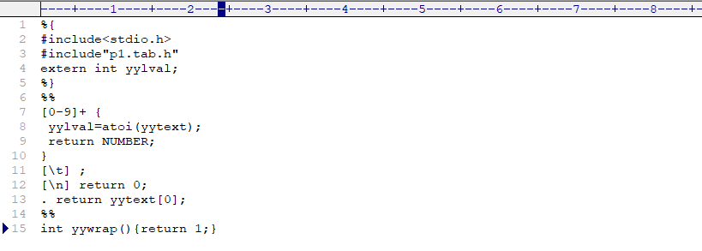

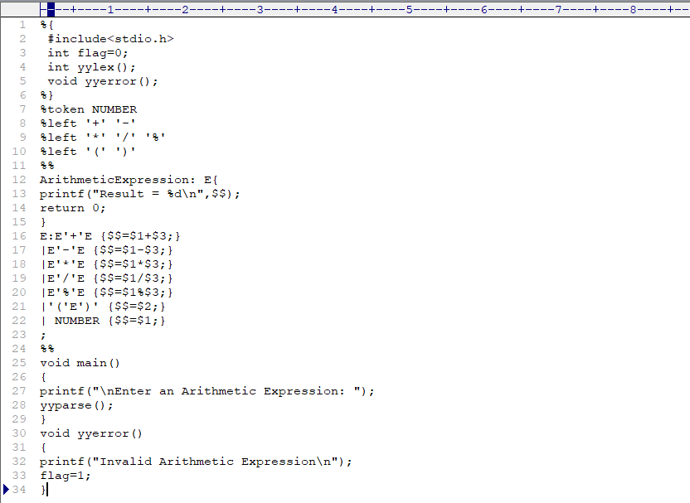**yacc**

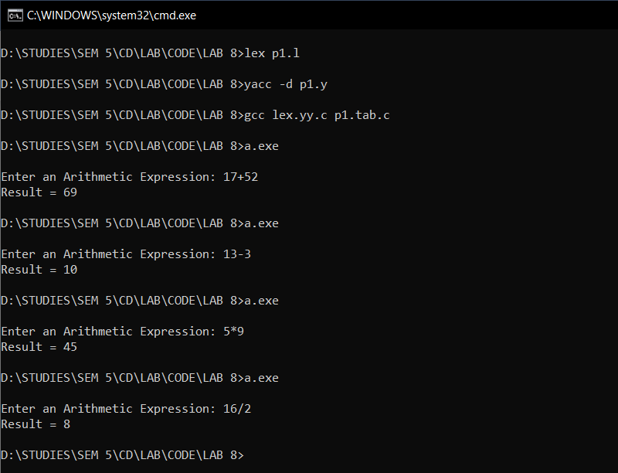**OUTPUT :-**

**2) Write a yacc program to implement logical operators.**

**CODE :-**

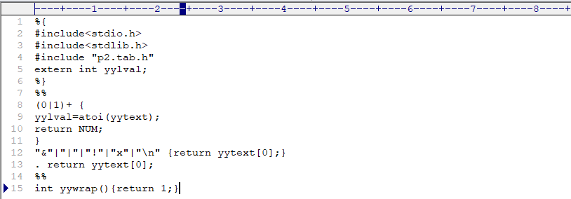**lex**

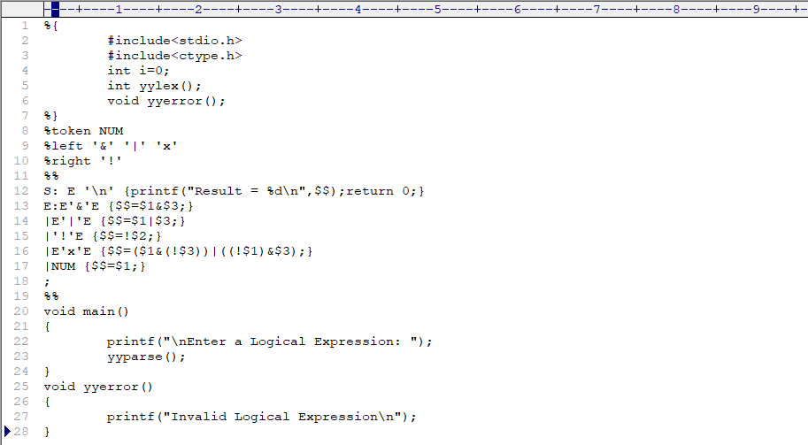**yacc**

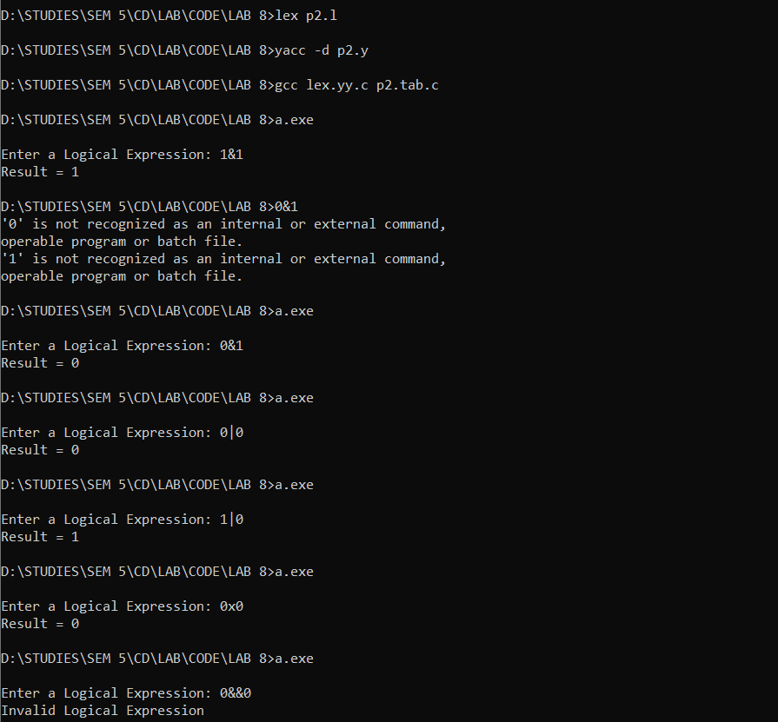**OUTPUT :-**

**3) Write a yacc program to check the syntax of for expression.**

**CODE :-**

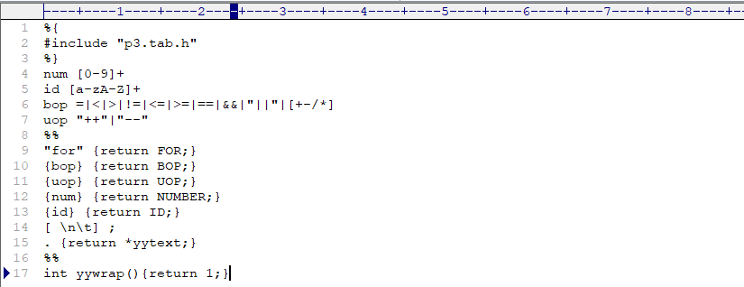**lex**

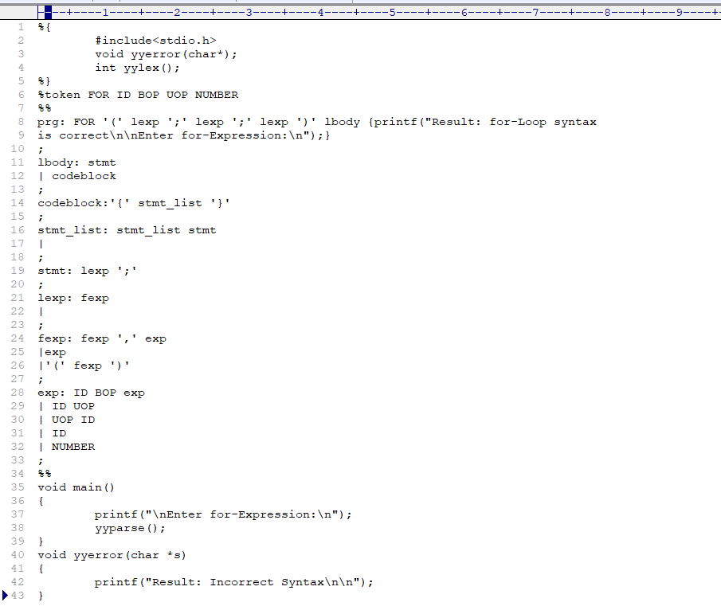**yacc**

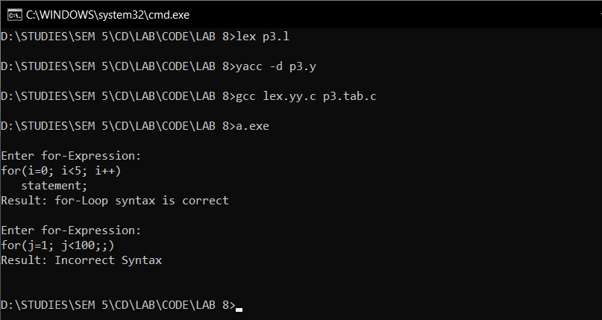**OUTPUT**